Objectives
- Explain in detail about HTTP Request and Response
  - HTTP Request and Response, HTTP Request Format, HTTP Response Format, Request URL, Request Method, Content-Type, User-Agent
    - Ref - https://en.wikipedia.org/wiki/Hypertext_Transfer_Protocol

- Explain the need and benefits of RESTful Web Services
  - REST stands for REpresentational State Transfer, lightweight, maintainable, scalable, underlying protocol is HTTP; composed of resources, verbs, header, body, response status code, client-server technology
    - Ref - https://www.chakray.com/advantages-of-rest-api/

- Demonstrate implementation of RESTful Web Service using GET method
  - @RestController, @GetMapping, invoking get request from browser, invoking get request from postman, bean transformation to JSON, get method with parameter, return array, @PathVariable
    - Dispatcher Servlet - https://docs.spring.io/spring/docs/5.1.9.RELEASE/spring-framework-reference/web.html#mvc-servlet
    - Spring REST (Getting Started) - https://spring.io/guides/gs/rest-service/
    - Request Mapping - https://docs.spring.io/spring/docs/5.1.9.RELEASE/spring-framework-reference/web.html#mvc-ann-requestmapping

- Demonstrate implementation of end to end testing of RESTful Web Service using MockMVC
  - @AutoConfigureMockMvc, MockMvc, @Test, get(), perform(), andExpect(), status().isOk(), jsonPath().exists, jsonPath().value(), status().isBadRequest(), status().reason test execution in Eclipse, test execution in command line using maven
    - Server Side Testing - https://docs.spring.io/spring/docs/5.1.9.RELEASE/spring-framework-reference/testing.html#spring-mvc-test-server

Output:

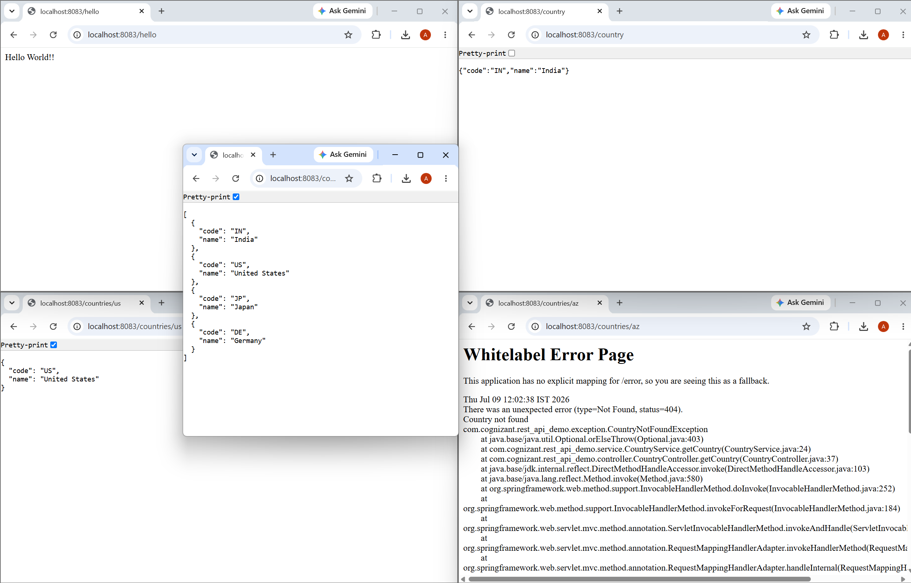
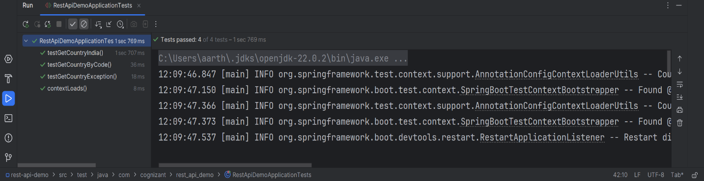
HTTP Request Response
To get a granular level of details about HTTP Request and Response, follow the steps below:
- Open the link https://tools.ietf.org/html/rfc7230 in browser. This document contains the standard definition for HTTP request response.
- Refer sample HTTP request and response in page number 7. This is the actual bytes of data that is transferred between the browser and server.
- Specific details about the request and response:
  - Request
GET /hello.txt HTTP/1.1
User-Agent: curl/7.16.3 libcurl/7.16.3 OpenSSL/0.9.7l zlib/1.2.3
Host: www.example.com
Accept-Language: en, mi
- Line 1 contains:
  - Method type - GET
  - Resource - /hello.txt
  - HTTP Version - HTTP/1.1
- Line 2 contains the details about the client
- Line 3 contains the server that will respond to this request
- The URL given in the browser is broken into Resource and Host in the HTTP Request

- Response
HTTP/1.1 200 OK
Date: Mon, 27 Jul 2009 12:28:53 GMT
Server: Apache
Last-Modified: Wed, 22 Jul 2009 19:15:56 GMT
ETag: "34aa387-d-1568eb00"
Accept-Ranges: bytes
Content-Length: 51
Vary: Accept-Encoding
Content-Type: text/plain

Hello World! My payload includes a trailing CRLF.
- Line 1
  - HTTP Version - HTTP/1.1
  - Response Status - 200 (this is means the request is responded successfully)
  - Response Message - Contains the response message
- Line 2 - Date of request
- Line 9 - Type of content returned. There is a list of predefined Content-Types. Based on Content-Type browser decides how the conent has to be visually displayed. Few examples below:
  - text/plain - Text content
  - text/html - HTML Document
  - application/json - JSON content
  - image/png - Image content of type PNG
- Last line contains the content of the resource.
  - ​​​​​​​In case of text/html, this will contain the HTML tags
  - In case of application/json, this will contain the JSON response
  - In case of image/png, this will contain the bytes to render the image

- To view the request and response details in browser, follow the steps below:
  - Open Chrome Browser
  - Press F12 to open the Developer Tools
  - Go to 'Network' table in Developer Tools
  - Open google search website in this browser window
  - Click on the first link available in the 'Network' tab
  - A new window will open in the right hands side. Observe the following details:
    - It will contain 3 sections. The data displayed will be similar to the HTTP request, response given above.
      - General
      - Response Headers
      - Request Headers
Hello World RESTful Web Service
Write a REST service in the spring learn application created earlier, that returns the text "Hello World!!" using Spring Web Framework. Refer details below:
Method: GET
URL: /hello
Controller: com.cognizant.spring-learn.controller.HelloController
Method Signature: public String sayHello()
Method Implementation: return hard coded string "Hello World!!"
Sample Request: http://localhost:8083/hello
Sample Response: Hello World!!
IMPORTANT NOTE: Don't forget to include start and end log in the sayHello() method.
Try the URL http://localhost:8083/hello in both chrome browser and postman.
SME to explain the following aspects:
- In network tab of developer tools show the HTTP header details received
- In postman click on "Headers" tab to view the HTTP header details received

REST - Country Web Service
Write a REST service that returns India country details in the earlier created spring learn application.
URL: /country
Controller: com.cognizant.spring-learn.controller.CountryController
Method Annotation: @RequestMapping
Method Name: getCountryIndia()
Method Implementation: Load India bean from spring xml configuration and return
Sample Request: http://localhost:8083/country
Sample Response:
{
"code": "IN",
"name": "India"
}
SME to explain the following aspects:
- What happens in the controller method?
- How the bean is converted into JSON reponse?
- In network tab of developer tools show the HTTP header details received
- In postman click on "Headers" tab to view the HTTP header details received

REST - Get all countries
Write a REST service that returns all the countries.
Controller: com.cognizant.spring-learn.controller.CountryController
Method Annotation: @GetMapping("/countries")
Method Name: getAllCountries()
Method Implementation: Load country list from country.xml and return
Sample Request: http://localhost:8083/countries
Sample Response:
[
{ "code": "IN", "name": "India"},
{ "code": "US", "name": "United States"},
{ "code": "JP", "name": "Japan"},
{ "code": "DE", "name": "Germany"}
]

REST - Get country based on country code
Write a REST service that returns a specific country based on country code. The country code should be case insensitive.
Controller: com.cognizant.spring-learn.controller.CountryController
Method Annotation: @GetMapping("/countries/{code}")
Method Name: getCountry(String code)
Method Implemetation: Invoke countryService.getCountry(code)
Service Method: com.cognizant.spring-learn.service.CountryService.getCountry(String code)
Service Method Implementation:
- Get the country code using @PathVariable
- Get country list from country.xml
- Iterate through the country list
- Make a case insensitive matching of country code and return the country.
- Lambda expression can also be used instead of iterating the country list
Sample Request: http://localhost:8083/country/in
Sample Response:
{
"code": "IN",
"name": "India"
}

REST - Get country exceptional scenario
In the previous hands on where we implemented getting country based on country code, what happens if the country code provided in the URL is not present.
Refer steps below to implement
- Create a new exception class com.cognizant.springlearn.service.exception.CountryNotFoundException
- Include below specified annotation at the class level in CountryNotFoundException class
@ResponseStatus(value = HttpStatus.NOT_FOUND, reason = "Country not found")
- In CountryService.getCountry() method include the logic to throw CountryNotFoundException if the country code does not exists in the list.
- In CountryController.getCountry() method include throws clause in method signature. This will respond to the caller of the web service with appropriate error message in JSON format.
- Test the service in postman and using curl command. Refer below for executing curl command.
Steps to invoke RESTful Web Service using curl command
- Open Git Bash
- Execute the below command
curl -i http://localhost:8090/country/az
Sample Request: http://localhost:8083/country/az
Sample Response:
{
"timestamp": "2019-10-02T03:27:54.521+0000",
"status": 404,
"error": "Not Found",
"message": "Country not found",
"path": "/country/az"
}

MockMVC - Test get country service
Using MockMVC test the get country service.
Create a test cases to test the following aspects:
- Test is the CountryController is loaded
- Invoke the service to get country and check in the response if it contains code as "IN" and name as "India"
Refer steps below to implement
- Test loading CountryController
  - Include CountryController instance variable in SpringLearnApplicationTests.java and autowire the instance variable using annotation.
@Autowired
private CountryController countryController;

- Include assertion in contextLoads() method to check if controller is loaded.
@Test
public void contextLoads() {
assertNotNull(countryController);
}

- Run the JUnit testing by right clicking on SpringLearnApplicationTests.java > Run As > JUnit Test
- This test can also be executed in command line using the following maven command in the root folder of the project. (Note: don't forget to include proxy details in the below command)
mvn clean test
- Check if the log in the constructor of CountryController is called.

- Test service to get the country
  - Include below imports
import static org.junit.Assert.assertNotNull;
import static org.springframework.test.web.servlet.request.MockMvcRequestBuilders.get;
import static org.springframework.test.web.servlet.result.MockMvcResultMatchers.status;
import static org.springframework.test.web.servlet.result.MockMvcResultMatchers.jsonPath;

import org.springframework.boot.test.autoconfigure.web.servlet.AutoConfigureMockMvc;
import org.springframework.test.web.servlet.MockMvc;
import org.springframework.test.web.servlet.ResultActions;

- Include @AutoConfigureMockMvc annotation for SpringLearnApplicationTests.java
- Autowire mock mvc in SpringLearnApplicationTests.java
@Autowired
private MockMvc mvc;

- Include a new test method in SpringLearnApplicationTests.java
@Test
public void testGetCountry() throws Exception {

}

- Include the following line in the new method that calls the service method. Execute the JUnit test and check if the test case is successful.
@Test
public void testGetCountry() throws Exception {
ResultActions actions = mvc.perform(get("/country"));
}

- Include the following line to check if the HTTP Status is 200, which means the call is successful. Execute JUnit test and check if the test case is successful.
@Test
public void testGetCountry() throws Exception {
ResultActions actions = mvc.perform(get("/country"));
actions.andExpect(status().isOk());
}

- Include the following line to check if the code is available in the reponse
@Test
public void getCountry() throws Exception {
ResultActions actions = mvc.perform(get("/country"));
actions.andExpect(status().isOk());
actions.andExpect(jsonPath("$.code").exists());
}

- Include the following line to check if the value of code is "IN"
@Test
public void getCountry() throws Exception {
ResultActions actions = mvc.perform(get("/country"));
actions.andExpect(status().isOk());
actions.andExpect(jsonPath("$.code").exists());
actions.andExpect(jsonPath("$.code").value("IN"));
}

- Using above two steps include checks for "name" attribute and check if it's value is "India"

MockMVC - Test get country service for exceptional scenario
Include MockMVC test that checks if correct response is received when there is an error.
Refer steps below to implement
- Include a new test method testGetCountryException() in SpringLearnApplicationTests.java
- Validate the error response using status(). Refer code below.
actions.andExpect(status().isBadRequest());
actions.andExpect(status().reason("Country Not found"));

